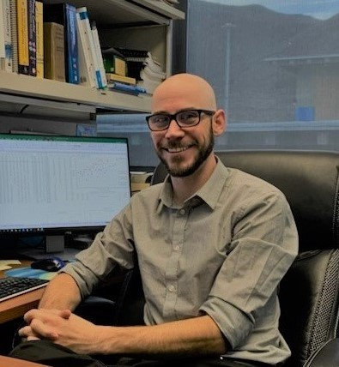

Mr. Casey Mentzer is the Process Engineer at the Truckee Meadows Water Reclamation Facility. In this role Mr. Mentzer is responsible for coordinating the day to day operation of the regional wastewater facility. Mr. Mentzer is a recognized expert in his field and has been published in several trade journals. He has also won numerous awards for his forward thinking and positive influence on the wastewater industry. He holds a B.S. in Chemical Engineering, a Master’s of Public Administration from the University of Nevada, Reno and is a registered Professional Chemical Engineer in the state of Nevada. He holds a Grade IV Wastewater Treatment Plant Operator certification.

Ms. Blaga Delic

